

INCOMING.US.ES

Student’s Manual

Welcome to the Universidad de Sevilla
Dear Student,
You have been accepted for a mobility period at the Universidad de Sevilla. In order to enrol in the appropriate courses, you need to complete several steps. Please keep this document for future reference.
- You need to establish your full credentials in the university systems using your assigned UVUS (Usuario Virtual de la Universidad de Sevilla). Go to the identity server (gid.us.es) and complete this step. Without an established identity, you will not be able to use any other system. This is a one-time task.
- Find out who your assigned Erasmus Coordinator is. At the Universidad de Sevilla, every School, Faculty, or Centre has a designated Mobility Coordinator. You should already know your destination School/Faculty/Centre; if not, this information should appear on your Learning Agreement or can be provided by your home university. Once you know your destination, find your coordinator’s email on this page. This person will be your main contact at the Universidad de Sevilla.
- You must validate your Learning Agreement using the incoming students application (incoming.us.es). You will need to enter all the courses you wish to apply for, as well as some information related to your mobility. Please note that your Mobility Coordinator (and possibly additional Mobility Coordinators, depending on the courses you apply for) must validate your application. This application is available in Spanish and English.
- Once your Learning Agreement has been validated, you must formally enrol at the Universidad de Sevilla using the same self-enrolment application as regular students, available at auto-matricula.us.es.
Access to the Application
Prior to using the Incoming Application, you need to complete your initial login at id.us.es and choose a password.
When entering the address https://incoming.us.es, the identification screen will appear. At the top right of the page, you can choose the English version.
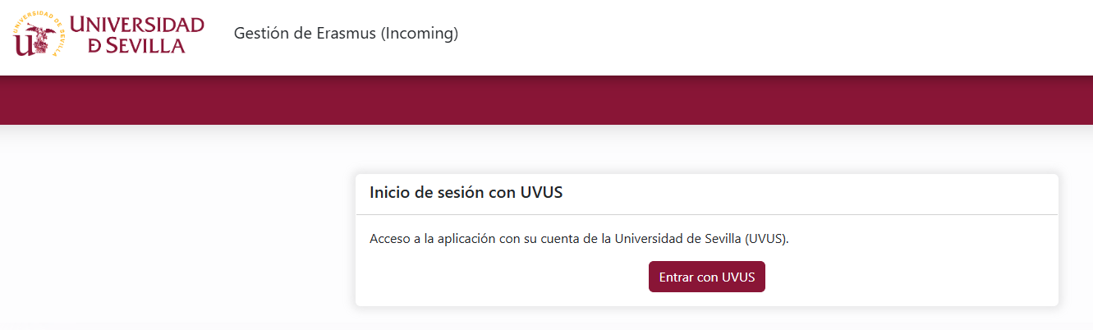

By clicking “Log in with UVUS”, the SSO screen will be displayed, where you must enter the username and password provided by the University of Seville.

Creating an Application
You can view ongoing applications or create a new one (“New application”). Only one application may be created per call.
Using the “Edit application” icon, you may continue completing the information of an application that has already been started.
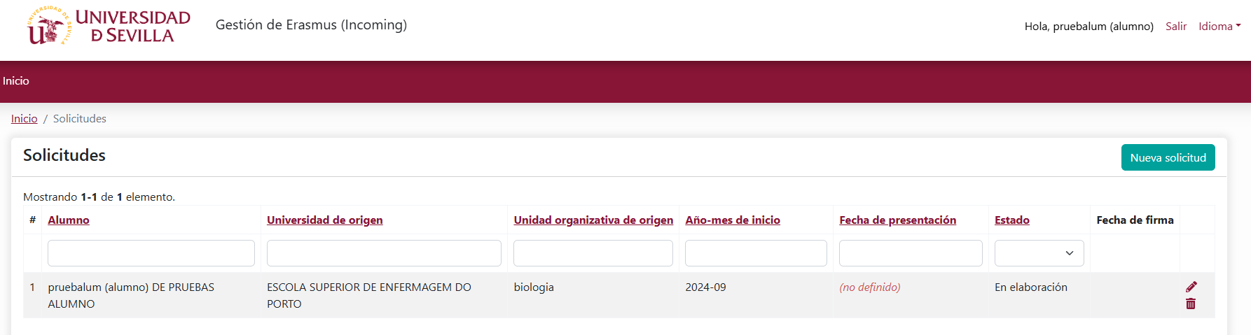

Editing an Application – Application Details

Pestaña ‘Datos de la solicitud’
This section is used to enter the general details of the learning agreement established at the home institution.
By clicking “Save”, the information is stored without being submitted for validation.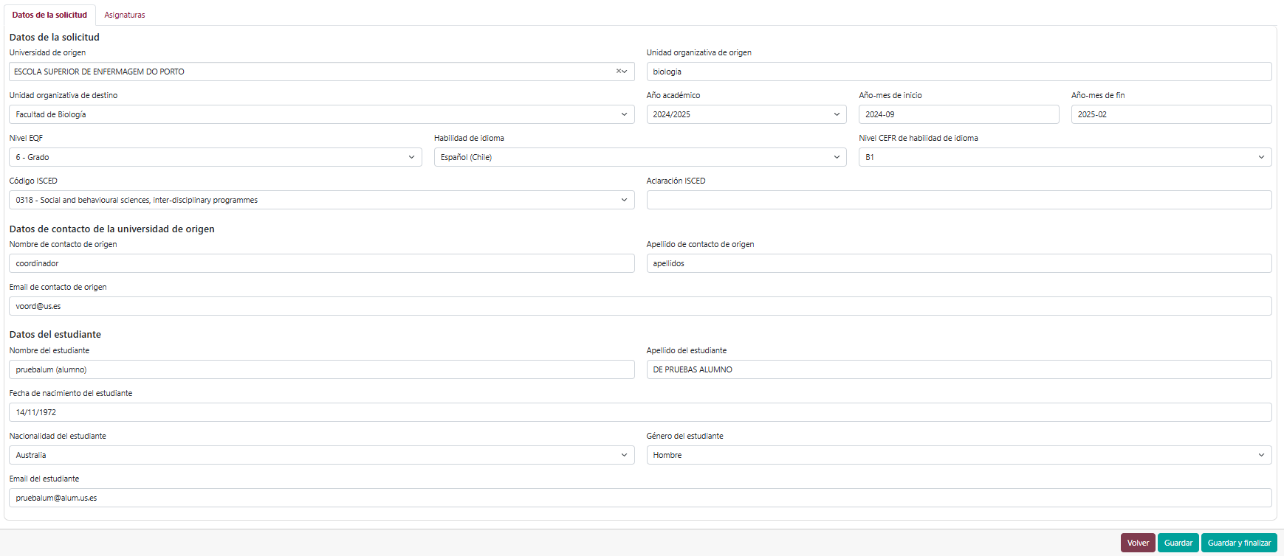

Editing an Application – Courses
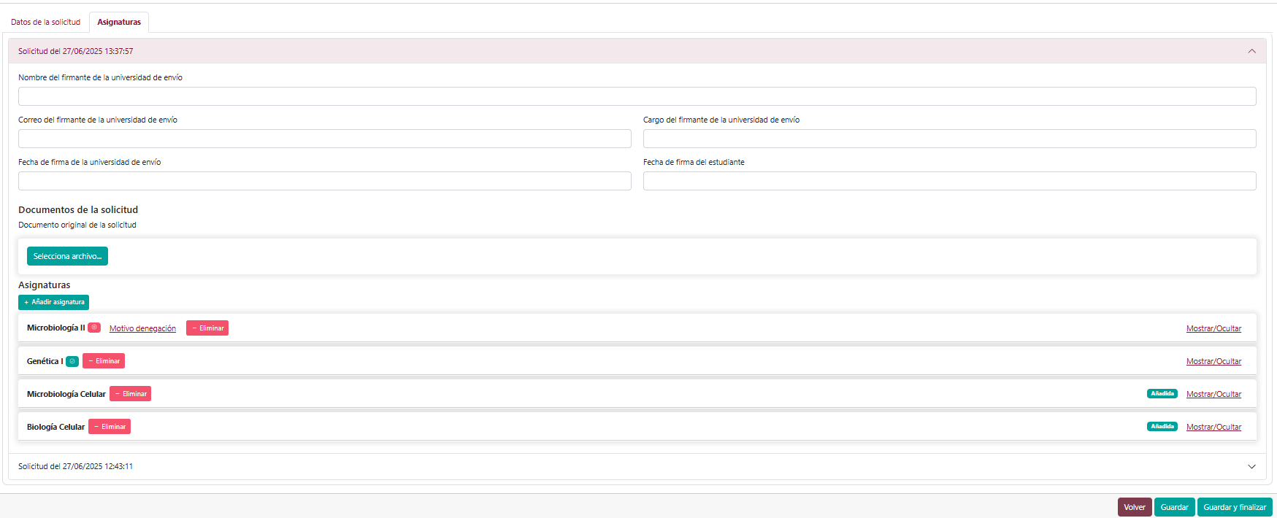
You will need to upload the original application document: the file containing the document issued by the home university.
Courses: Click “+ Add course”. A new line will appear.
.Click “Show”.

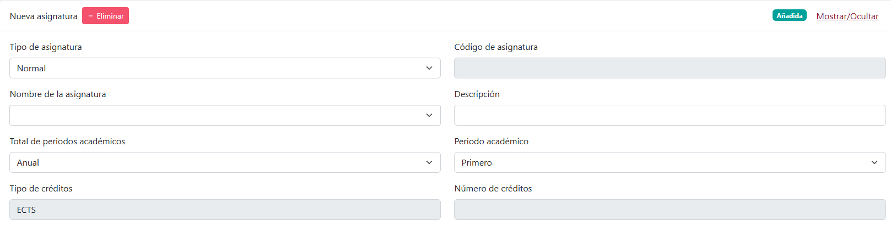
In the “Course name” field, you can search by name and select the appropriate course. The “Course code” field will be filled in automatically.
Courses can also be deleted in this tab.
The acceptance or rejection status of each course is displayed via a side icon:
Course rejected (and reason):
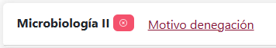
Course accepted and validated.
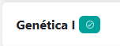
By clicking “Save”, changes are stored and can be edited later. By clicking “Save and finish”, the application is submitted for validation by the centre and can no longer be edited. Son obligatorios los siguientes campos:
Mandatory fields:
- Name of the coordinator (the person signing your LA) at the sending university
- Email address of the coordinator at the sending university
- Position of the corrdinator at the sending university
- Signature date of the sending university
- Student’s signature date
Validation
Once the centre administrator completes the validation and signs the application, the student receives an email with information about the process.
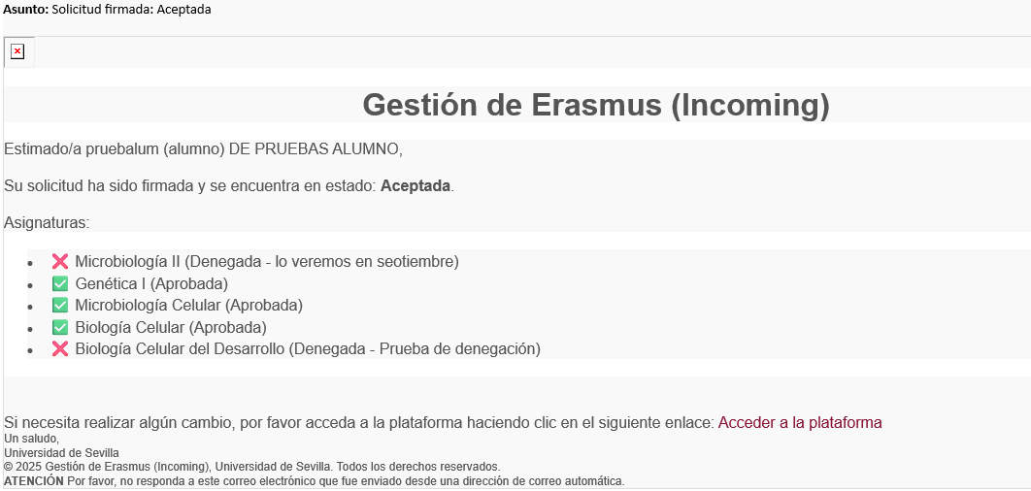
Upon accessing the system, the applications screen displays the current status.
Upon accessing the system, the applications screen displays the current status.
If the student does not agree with any of the rejections, or if the learning agreement has been modified at the home university, they may click the reopening icon. The process is then repeated by deleting and adding courses as appropriate.
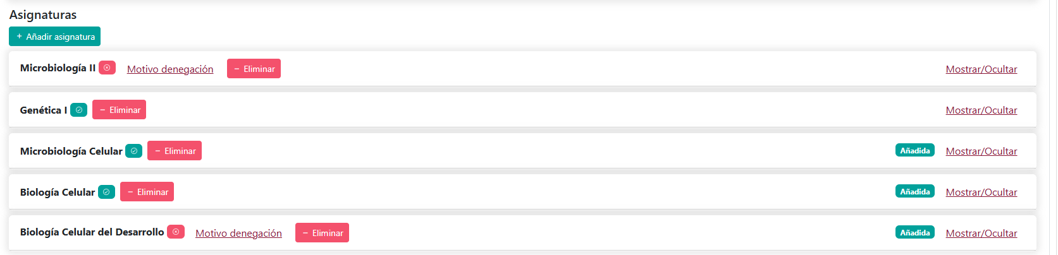

ONCE YOUR APPLICATION IS VALIDATED, YOU WILL NEED TO CONTINUE ON TO THE ENROLMENT APLICATION.

